How to Setup Swagger in ASP.NET WebAPI Project

**Step 1**: Create or Open Web API project in visual studio

**Step 2**: Install nuget package in project



After installation, make sure below highlighted reference added

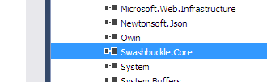

In addition, validate there should be swaggerconfig.cs under App_Start folder

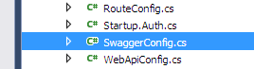

**Step 3:** Configure the project to extract documentation in separate xml file

Project Properties -> Build Tab

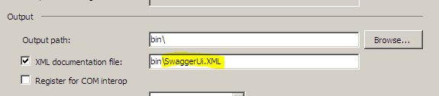

Document the endpoint as highlighted below and make the build, ensure swaggerui.xml file under bin folder.

|  |  |
| --- | --- |
|  |  |

**Step 4:** Configure swaggerconfig to use xml file, it is required for the documentation that you would see in swagger UI

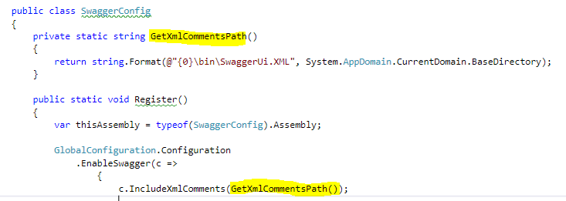

Step 5: Document the endpoint/code like exemplified below

For example, Employee class is response of endpoint

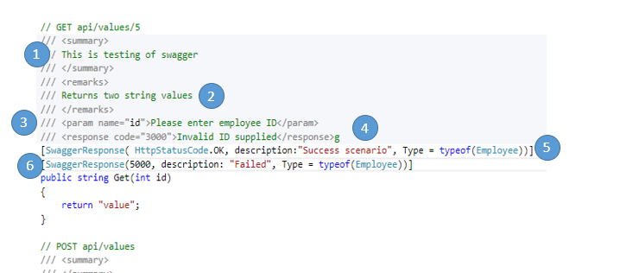

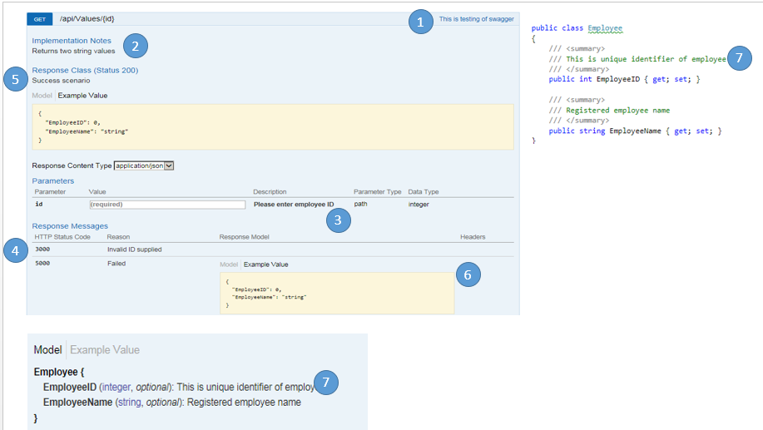

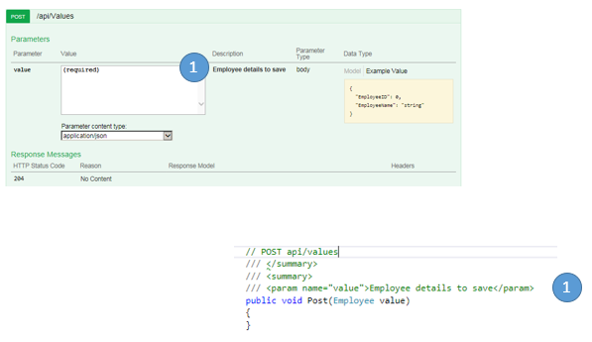

Swagger is configured now; hit the url in browser and check.

<project url>/swagger/ui/index